**Foliar Disease Detection Using ML and DeepLearning**

KIET Group of Institutions, Ghaziabad

Prof.Shalini Kapoor

[1] Umang Pratap Singh,[2] Tushar Kundoo,[3] Saurabh Mandal

**Abstract**

*The classification methods that may be used to classify plant leaf diseases are surveyed in this research. The 7.6 billion people on the planet may be fed with the help of contemporary farming techniques. People continue to experience malnutrition despite having access to enough food. Plant diseases affect both the quantity and the quality of the overall harvest. A number of challenges must be overcome when developing an image processing model for prediction or classification applications. For a farmer, it might be challenging to recognize illness signs visually. A computerized image processing technology is used for crop protection in big frames so that unhealthy leaves may be identified utilizing the color information of the leaves. There are several classification methods, including the SVM, Probabilistic Neural Network, k-Nearest Neighbor Classifier Genetic Algorithm and Principal Component Analysis. Because diverse input data might produce results of varying quality, choosing a classification technique is always a challenging undertaking. Classifications of plant leaf diseases are widely used in many industries, including agriculture, biotechnology, and scientific research.*

*Keywords: K- means clustering, ANN, SVM, Neural network.*

**Introduction**

*Plant diseases cause yield reductions that have a direct influence on the domestic and international food production systems and lead to financial losses. About 20% to 40% of the world's food output is lost due to plant diseases and pests, according to the FAO of the United Nations has reported that 13% of global crop yield losses are due to plant diseases. This highlights the importance of identifying and preventing plant diseases to minimize these losses. One method for identifying plant diseases is by analyzing images of plant leaves, using a technique called "image processing" which falls under the field of signal processing. By leveraging the power of artificial intelligence, specifically machine learning, we can extract meaningful information from these images to accurately detect and diagnose plant diseases and thinking performs tasks itself or provides instructions on how to carry them out. Understanding the training data and incorporating it into models that should be helpful to humans is the basic goal of machine learning. Thus, it may help in making wise selections and forecasting the right output utilizing the vast training data. Leaf color, leaf damage level, leaf area, and leaf texture characteristics are utilized for classification. Several forms of plant diseases damage various plant organs. Plant pathologists can most easily identify foliar diseases, which are plant diseases that manifest symptoms on leaves. Fungal diseases are a major cause of yield losses, accounting for up to 50% of the total losses. As a result, many researchers are using computer vision, machine learning, and deep learning techniques to detect and diagnose plant diseases using images of plant leaves. Effective diagnosis of plant diseases involves early detection of diseases, identifying multiple diseases in different crops, estimating the severity of the disease, determining the appropriate amount of pesticide to apply, and taking practical measures to manage the disease and prevent its spread.*

**Existing Work**

*Prior studies on detecting leaf damage using CNN provides an example of how to recognize ans classify leaf disease using image processing techniques like as*

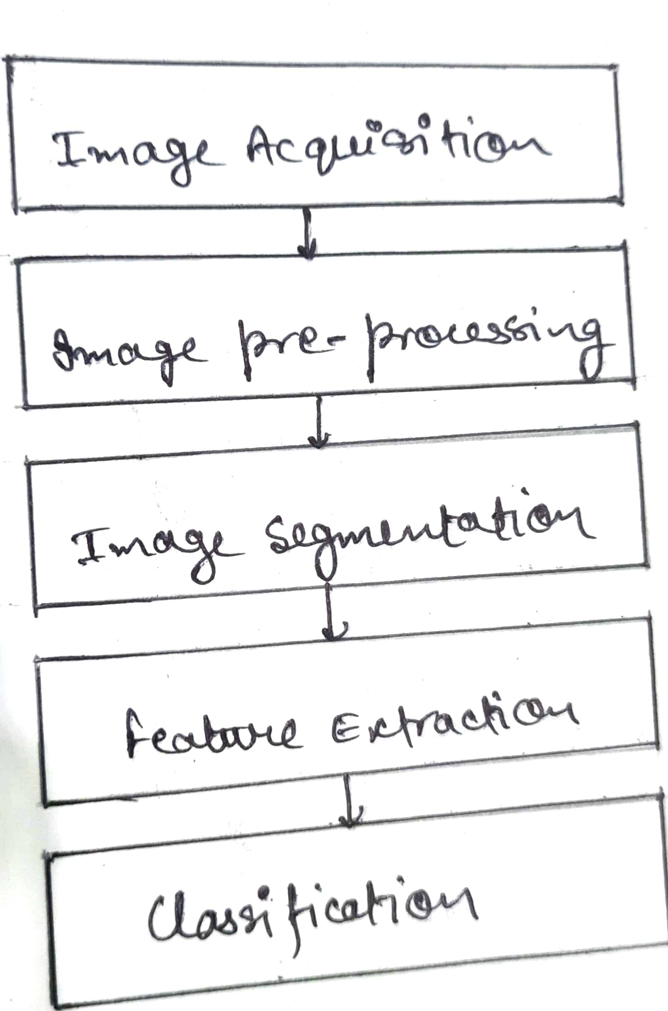

**Fig: Block Diagram of Feature Based Approach**

*Image acquisition refers to the phenomena of capturing an image and storing it digitally, such as on a digital camera or other digital medium. Before any processing can be done on the image, it is necessary to pre-process it in order to improve its quality and remove any unwanted distortions. The important objective of image pre-processing is to enhance the desired characters of the image and improve the details contained within it, making it more suitable for subsequent processing and analysis using tools such as MATLAB*. ***Many approaches are used in preprocessing, such as dynamic image size improving image and morphological processes, noise filtering, image conversion, and image enhancement.*** ***Image segmentation is employed in K-means clustering is a method for grouping several images so that at least one of the clusters has an image with a significant portion of an unhealthy region. Application of the k means cluster algorithmic method results in the classification of the objects into K different categories for every set of qualities. Following the formation of clusters, GLCM is used to extract texture characteristics.***

**Related Works**

***In this section, we discuss pertinent initiatives in categorization problems utilizing deep learning architectures. Deep learning techniques have generally been the subject of much research for applications such as object recognition and image categorization. When used to solve recognition and classification issues, convolutional neural networks (CNNs), a deep learning technology, achieve state-of-the-art performance in picture classification.The first CNN architecture known as MobileNet for object recognition was evaluated using the dataset for tomato disease. To determine the degree of tomato leaf disease from photos of tomato leaves, pre-trained CNN architectures VGG16, MobileNet, and ResNet50 were implemented. Performance was improved by adding ResNet50 features to the traditional CNN model.***

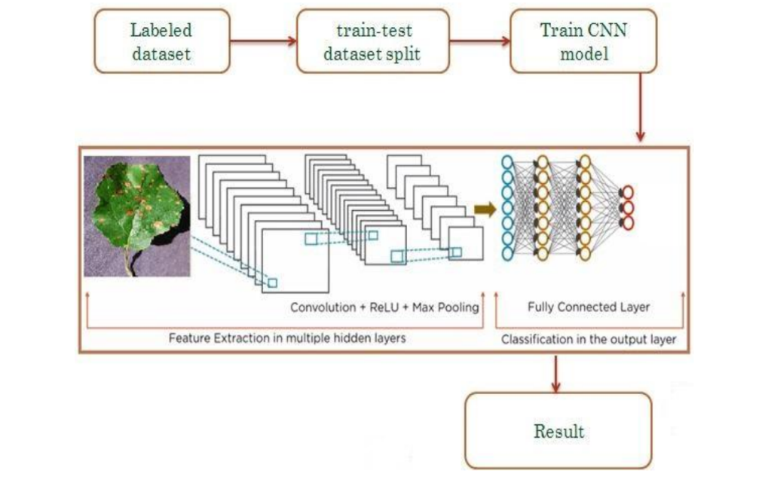

**Fig: Proposed Workflow**

***The spatial links between the image's constituent parts are not taken into consideration by CNN architectures, making them ineffective for geometric transformations. By routing features from one layer to another in CNN, the max-pooling layer has a tendency to lose data. They are unable to model the rotational invariance of an item.The section presents a Capsule Network with Dynamic Routing algorithm to alleviate the shortcomings of CNN design. Capsule networks were used in the experiments to classify illnesses based on medical imaging, and they performed better than regular CNN in doing so.***

**Dataset**

*In this survey, we utilized the PlantVillage dataset, which is openly attainable collection of images for identifying plant leaf diseases. The dataset was curated and maintained by Sharada P. Mohanty and others, and contains over 87,000 RGB photos of both healthy and diseased plant leaves, with 38 different disease classes. However, for the purpose of our experiment, we selected only 25 disease classes to test our method, which are listed in the table*.

**Table - Dataset Specifications.**

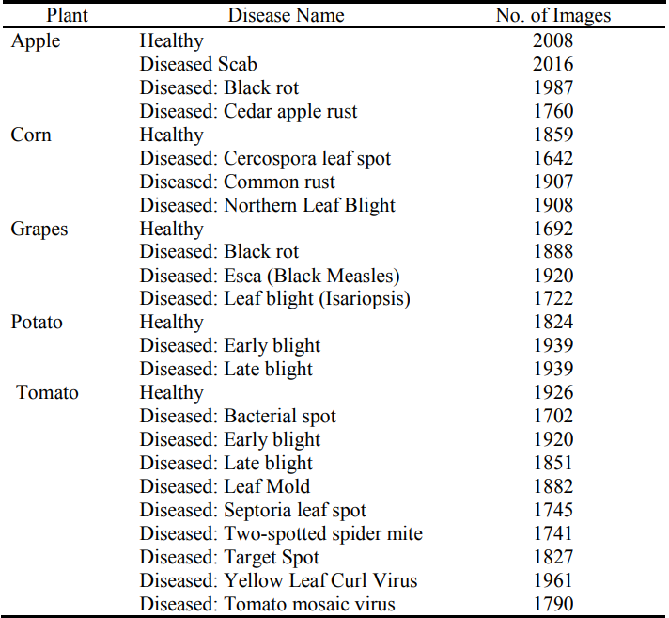

**The model consists of 5 phases:**

**A.Feature Extraction and Data Preprocessing**

*For computer vision-based systems to yield accurate results, it is crucial to prepare the data correctly. One critical aspect of data preparation involves removing background noise from the image before extracting the essential features. By converting an RGB image to grayscale, the image is simplified, making it easier to process.The thresholding technique is then used to binaries the picture. The minor gaps in the foreground are then filled using morphological transform on the binarized picture. Texture, Shape and color attributes are now retrieved from the picture following segmentation. The parameter and area of a leaf are estimated using contours. A outline is a line that connects all the points on the boundaries of objects that share the equal hue or devotion. In addition, the standard and mean deviation of each RGB color channel are also calculated. The image is initially transformed from RGB to HSV color space, and the proportion of pixels with hue (H) channel pixel intensities ranging from 30 to 70 is calculated and divided by the total number of pixels in that channel. This is done to determine the quantity of green color present in the image. Calculating the non-green portion of a picture involves removing the green component from 1.*

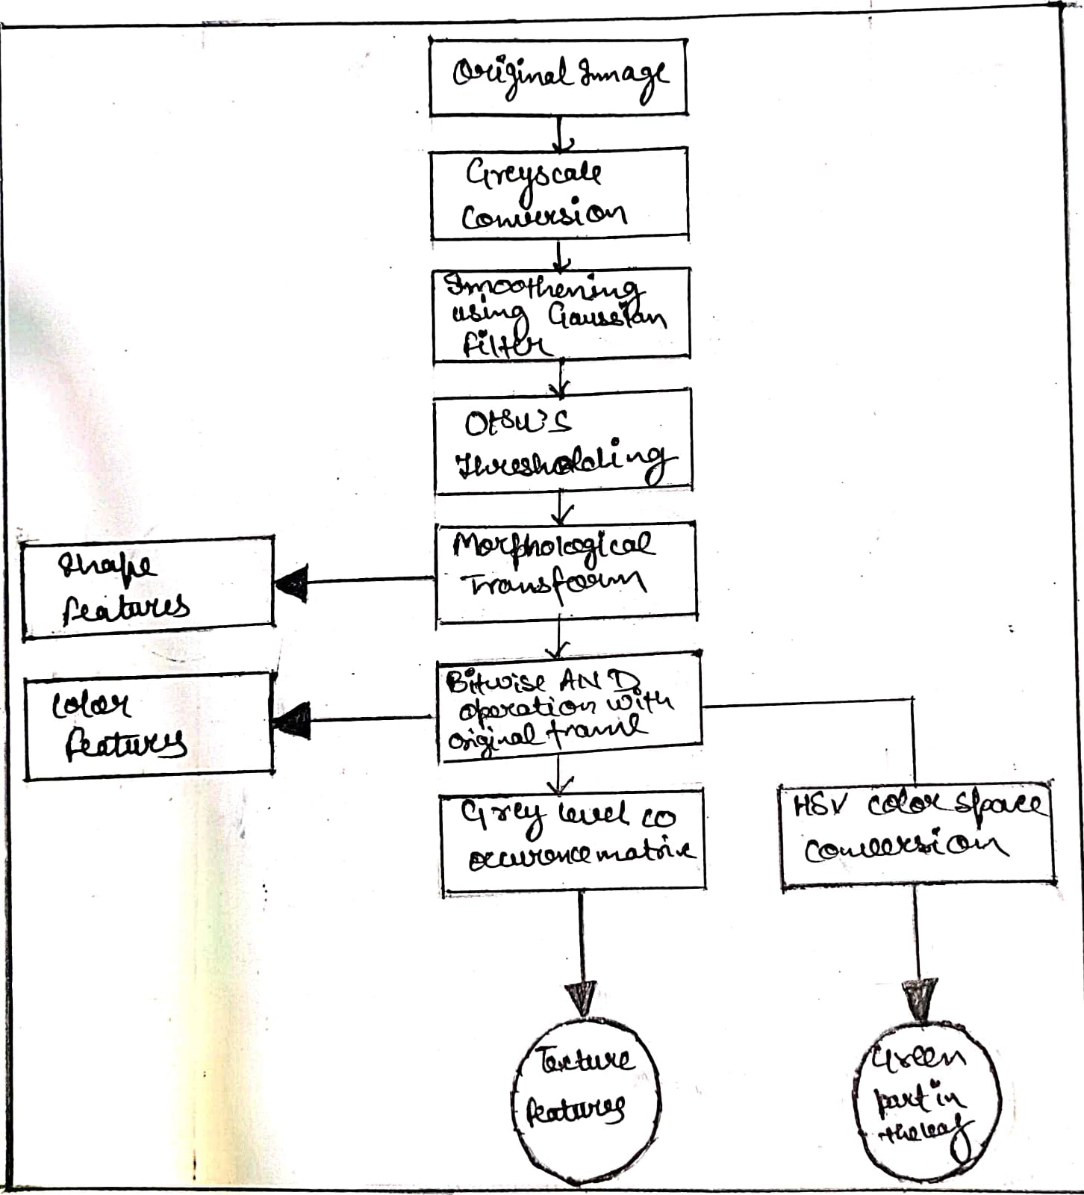

**Fig: Steps for feature extraction and data processing**

**B.Image Pre-Processing**

*Unwanted noise has been eliminated from photos that have been gathered using image pre-processing. Research has proposed a number of concept preparation methods. An optical inspection's dependability can be enhanced by pre-processing of image.A more simple or quick review consists of many filter processes that highlight or diminish certain visual elements. With a few clicks, users may easily improve a camera image. Many graphics processes, such as cropping, rotating, normalizing, contrast boosting, filtering, and angle correction, are involved. Digital photographs can include noises like dust, dewdrops, and insect faces that can be removed using image preprocessing. Distortion and Noises from shadow effects and water drops can also be removed using various types of noise reduction filters. The real image was converted into a new color space using primarily three image pre-processing techniques. This new color space is basically similar to the original image but varies in certain ways. As previously said, picture resizing, image restoration, and image enhancement include: Steps in this process of engagement.*

1. Resize

*Original photos were downsized to a fixed resolution of 640 × 480 pixels to better fit the available processing and memory resources.*

2. Noise Restoration

*When a camera and an object move, the shutter opens improperly, the environment is disturbed, and the focus is off, all of these things can produce noise.*

3. Image Enhancement

*For the purpose of improving digital photographs for presentation or subsequent study utilized image enhancement*.

(𝑥) = 0.114 ∗ 𝐵 + 0.2989*R + 0.5870*G

*Eqn: 1 RGB to grey conversion equation*

**C.Disease detection and classification**

*Disease identification is carried out in two phases, namely the kind of crop and the type of illness. Convolutional Neural Network is used to facilitate this. Transfer learning will be used to develop the model. It is a method in which the existing models are used to build the new ones. Classification also functions as fully linked classifiers that are created utilizing a variety of model learning. By flattening the photos, we achieve the following by creating vectors with a single dimension from the pooled images. It becomes much simpler to categorize the photographs once they have been turned to vectors. We obtain specific numerical values in relation to distinct classes using the trained model. If a leaf is healthy, it will be labeled as such without any further classification. However, if there is a disease present, black dots on a gray scale will indicate it and the disease will be classified with a certain level of confidence. This classification process uses two numerical arrays and determines whether the leaf is healthy or sick based on the dataset provided. Identifying plant diseases through classification is a crucial and efficient process that provides accurate results.*

**D.Image Segmentation**

*The photos have been divided into parts for examination using image segmentation. In accordance with the necessary characteristics, images have been transformed into another format. The steps involved in segmenting an image include background removal, and picture analysis. In favour to distinguish the contaminated region from the background, image partition is carried out by choosing the proper threshold range. The bottom and top of the picture histogram are used to select the threshold values. One method at the threshold has been shown to be unsuccessful due to the non-uniform distribution of the illness zone. As a result, a partition-level entry depend on partition of pixels was suggested.The query image is separated into a division for disease and a section for health based on a fuzzy logical grading design. The threshold has been set at the valley's bottom if the histogram shows a severe and deep valley between two peaks. If not, it is impossible to apply this technique to make items stand out from the backdrop. As a result, the Otsu technique has automatically chosen the best threshold value.*

**E.Image Analysis and Diagnosis**

*In photos of paddy leaves, the histogram as well as the intensity and saturation parts of the green, blue and red components are determined. Nevertheless, the only factor that affects how accurate the results are is the Hue components.As a result judgements were solely based on Hue histogram analysis.With the help of the extracted characteristics, the image is examined to see if any of the three disorders mentioned above are present. In order to segregate paddy leaf photos depending on the infected illness, color histogram and pixel layout were utilized. To extract contours from photos, utilize the Border tracing technique. Before examining an image's characteristics, the image has been turned into a histogram*.

**Implementation work**

*The categorised leaves of tomato, potato, grape, and apple plants have 24 distinct types of labels. Information on Apple labels includes the following: healthy rust, scabs, and black rot. specifically: Cercospora of Corn Grey spot, healthy corn, corn blight, and corn rust. The individual grape labels are Leaf blight, Black rot, Esca, and healthy. The dataset consists of 31,119 images of various produce, including tomatoes, apples, maize, grapes, and potatoes. The images were downsized to 256 x 256 and divided into training and testing datasets with an 80-20 split. Out of the total dataset, 24,000 images were utilized for developing the CNN model. The dataset includes images of plants affected by different pests and illnesses such as bacterial spot, early blight, healthy, late blight, leaf mould, septoria leaf spot, spider mite, target spot, mosaic virus, and yellow leaf curl virus. The objective of the model is to classify potato images into three categories: early blight, healthy, and late blight, which can help identify and manage diseases effectively.*

*The convolution layer uses a convolution method to extract information. As the depth increases, the complexity of the recovered characteristics increases. The number of filters steadily rises as we move from one block to the next, but their size is constant at 5*5. There are 20 filters in the starting convolution block, 50 in the 2nd, and 80 in the 3rd. The size of the feature maps was lowered as a result of the pooling layers being used in each of the blocks, which required more filters. After the convolution procedure is used, feature maps are null-padded to retain the dimesnions of the image. To shorten the length, utilise the max pooling layer.*

*Transfer learning is a technique for sharing knowledge that employs 224*224 fixed-size pictures and requires the least amount of training data possible. Transfer learning is useful for transferring knowledge from one model to another. Sentiment analysis, activity recognition, software defect prediction, and plant categorization are just a few of the activities that have utilised transfer learning. In this study, the performance of the suggested Deep CNN model is compared to that of the well-liked VGG16 transfer learning technique. Three layers come after a stack of convolutional layers. The third device employs a 1000-way ILSVRC classification and has 1000 channels, compared to the preceding two devices' 4096 channels apiece. The last layer is the soft-max layer. The entirely connected layer design makes it easier to identify the leaf disease. All hidden layers have the ability to rectify. Re-Lu It should be noted that none of the networks use Local Response Normalization (LRN), which has no positive effects on the dataset's performance. Network nonlinearity exists in repaired linear units..*

**Results and discussion**

*The table displays the performance metrics of each model developed for different plants, and it shows that the accuracy scores and f1 ratings are quite similar. However, a significant number of incorrect predictions, both positive and negative, contributed to this similarity. The average accuracy achieved was 93%, and confusion matrices were used to evaluate the number of true positives, true negatives, and accurate predictions. Additionally, the receiver operating characteristic (ROC) curve was plotted for each model to evaluate their performance at various classification thresholds. The ROC curve is a graphical representation of a classification model's performance, with the true positive rate and false positive rate being the two key parameters used to assess the model's efficacy.*

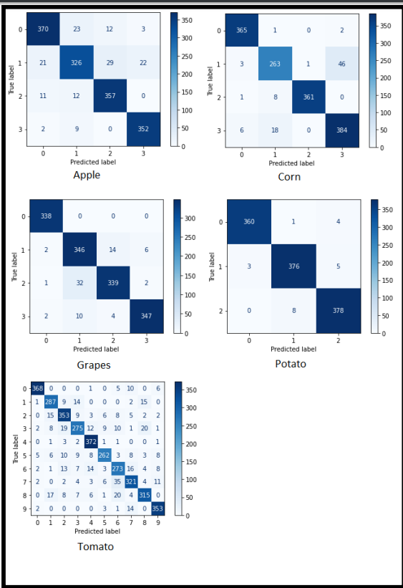

**Fig: Confusion matrices for all the models**

*With the hope of increasing accuracy, the CNN (Alexnet) is being tested for the detection of leaf diseases. The database is split into two datasets, training and testing, using an 80/20 splitting ratio. CNN determines if a leaf is healthy or ill, and if so, it also forecasts the type of sickness. The CNN model was trained using a 10-epoch starting learning rate of 0.001. The activit of the CNN model on the testing dataset during training.* *Apple leaf confusion matrix illustration. 99% of the time, Apples leaves are accurate. Table 1 provides a summary of each plant's categorization accuracy. The total degree of accuracy is 97.71%. Examples of categorization made using convolutional neural networks on some randomly chosen photos from the testing dataset. The upper right corner of each image shows the accuracy percentage for the related plant leaves.* *By allowing for the early diagnosis of illnesses, this effort will help in the automatic identification of plant leaf disease and boost agricultural productivity. The accuracy of detecting tomato leaf disease may be improved by evaluating transfer learning and other CNN models.*

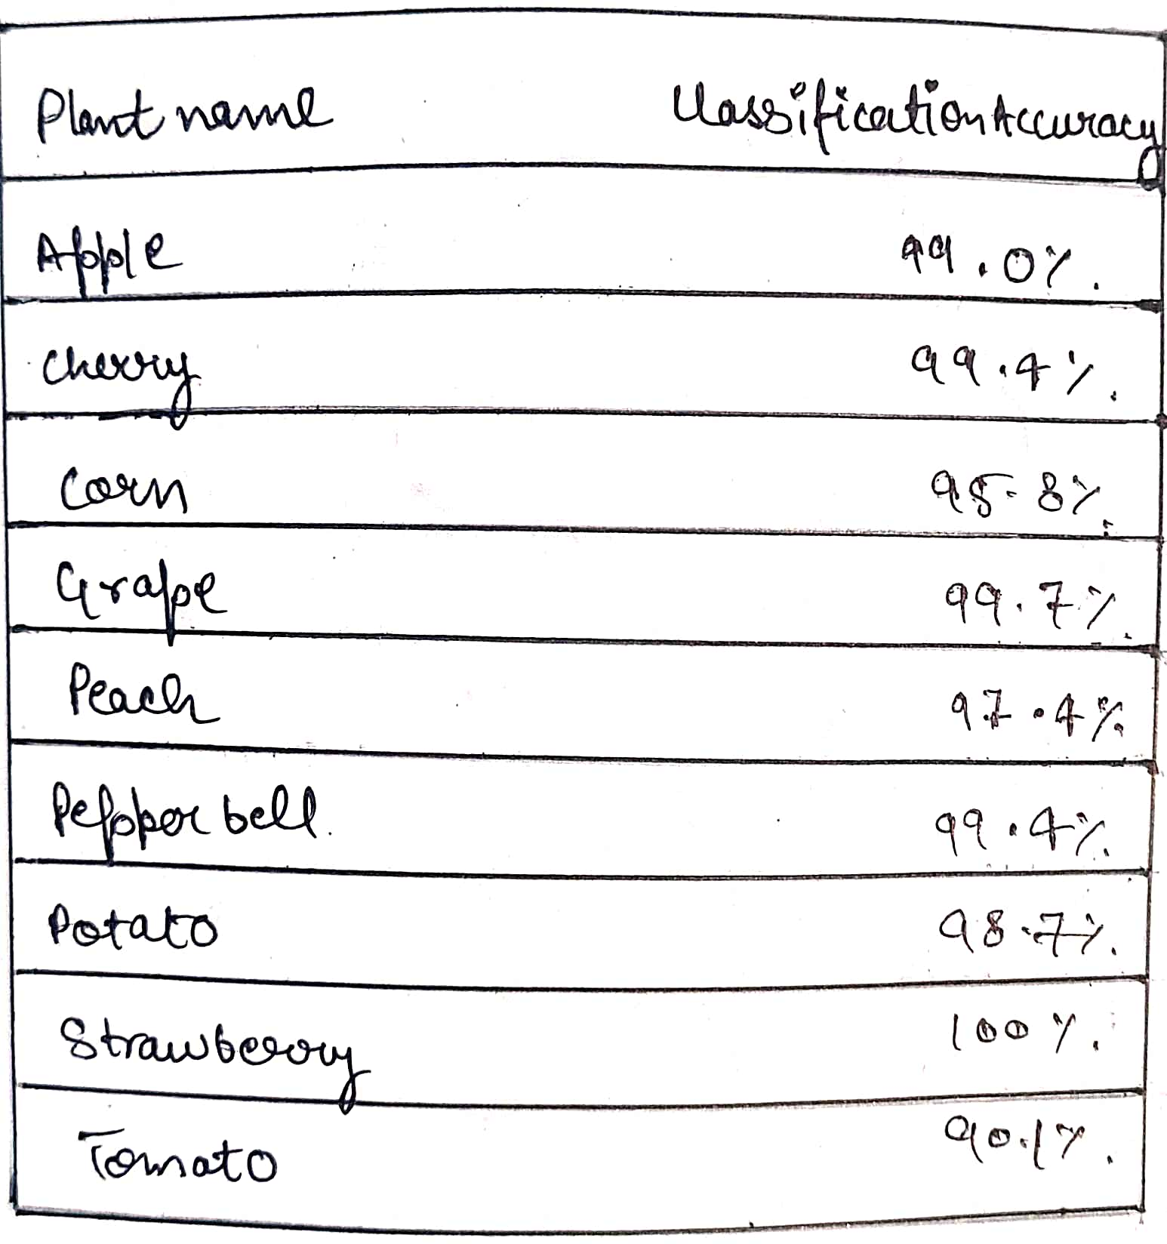

**Table: Classification Accuracy of leaves of plantsConclusion**

*This article examines the many paddy diagnosis techniques utilizing machine learning and image processing. Before using classification or image processing methods to detect the disease, the initial steps are characterized as picture acquisition, image processing, segmentation, and feature extraction. Several studies have changed pictures from the RGB color space to another color format or a grayscale since it is simple to obtain the threshold value of the histogram equation. In the process of processing images, noise has been recognized as a key issue that has to be resolved. It is essential for picture scaling and image improvement in machine learning classification research. The K-mean cluster approach is also utilized to remove the infected portions from the picture during the segmentation process. The Otsu method was used to choose the threshold value range. The three key characteristics that may be used to identify illnesses from a photograph of a paddy leaf are color, shape, and texture. SVM and ANN machine learning principles can be applied to diagnose problems using these features. The classification algorithm is mostly responsible for the diagnostic procedure' accuracy. A histogram equation with multiple values has provided some accuracy in differentiating rice leaf diseases in place of a machine learning process.*

**References**

*1.Literature Review of Diagnosis Rice Leaves Diseases Using Image Processing R.I.L.Jayasooriya, Samantha Mathara Arachchi University of Colombo School of Computing, 35, Reid Avenue, Colombo 7, Sri Lanka.*

*2.Plant Disease Detection Using Image Processing and Machine Learning Pranesh Kulkarni1,Atharva Karwande1,Tejas Kolhe1,Soham Kamble1,Akshay Joshi1,Medha Wyawahare1 1 Department of Electronics and Telecommunication,Vishwakarma Institute of Technology, Pune, India.*

# *3. Image-Based Crop Leaf Disease Identification Using Convolution Encoder Network written by Indira Bharathi and Veeramani Sonai Reviewed: August 9th, 2022 Published: October 21st, 2022.*

*4.Plant Disease Detection using Machine Learning by Ms.Nilam Bhise1,Ms.Shreya Kathet2,Mast.Sagar Jaiswar3,Prof.Amarja Adgaonkar4 1 Student, Department of Information Technology,Excelsior Education Society's K.C. College of Engineering & Management Studies & Research, Thane, Maharashtra, India.*

#### 5.Plant Leaf Disease Detection using Deep Learning by Mr. Thangavel. M -AP/ECE ,Gayathri P K ,Sabari K R, Prathiksha V from Knowledge Institute of Technology,Salem.

*6.Implementation of Improved Machine Learning Techniques for Plant Disease Detection and Classification Ibrahim M. Adekunle Department of ICT,Osun State University, Nigeria.*